JustFour
Tech Stack & Architecture
MVP · May 2026

Here's the full stack recommendation, then the architecture diagram, then the DB schema.

The Stack — 6 decisions

Framework: Next.js 14+ (App Router) — your developer knows it, streaming responses work natively via Server Actions and Route Handlers, and Vercel deployment is essentially zero-config. No alternative worth considering.

Hosting: Vercel — free tier handles 20 founders without config. Scales to 200 weekly users without architecture change. Auto-deploys from GitHub. Set up a preview environment from day one — Vercel creates one per branch automatically.

Database + Auth: Supabase — this is the most important single decision. It gives you Postgres (what your developer knows), magic link auth built in (saves 2 days of custom work), a Mumbai region (ap-south-1) which matters for Indian latency, and a free tier that covers validation. When you need Stripe webhooks later, the Postgres schema is already extensible. Don't split auth and DB across two providers — that's unnecessary complexity at this stage.

AI: Anthropic API + Vercel AI SDK — the SDK handles streaming, the useChat hook on the frontend, retry logic, and the message history format. Without it, streaming in Next.js requires custom SSE handling which is a week of plumbing. With it, streaming chat is ~50 lines.

Email: Resend — $0 for the first 3,000 emails/month. Supabase auth uses it natively for magic links. Clean API, React Email for templates later. Don't use SendGrid or Mailgun — overbuilt for this stage.

Payments: Razorpay (post-validation) — India-first, good INR support, Stripe-like API, your developer will find it familiar. For the 20-founder validation: manual payment collection via Razorpay payment link + you flip is_paid = true in the DB. Full webhook-based subscription billing is post-validation. One nullable payment_ref column in users is all you need to make this extensible.

UI: Shadcn/ui + Tailwind + Zustand + react-markdown — Shadcn is unstyled-enough that the product can look like itself, not like a template. Zustand is the right state manager for a multi-stage chat app. react-markdown with remark-gfm for rendering AI responses.

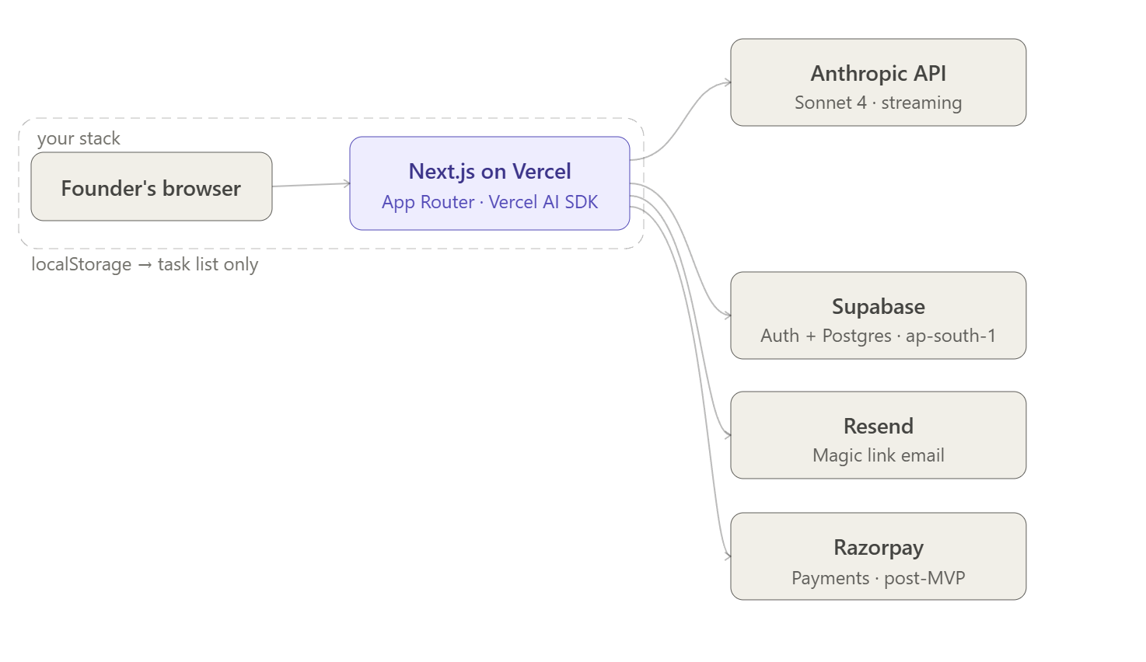

DB Schema — the 4 tables that matter

Click any node to explore.
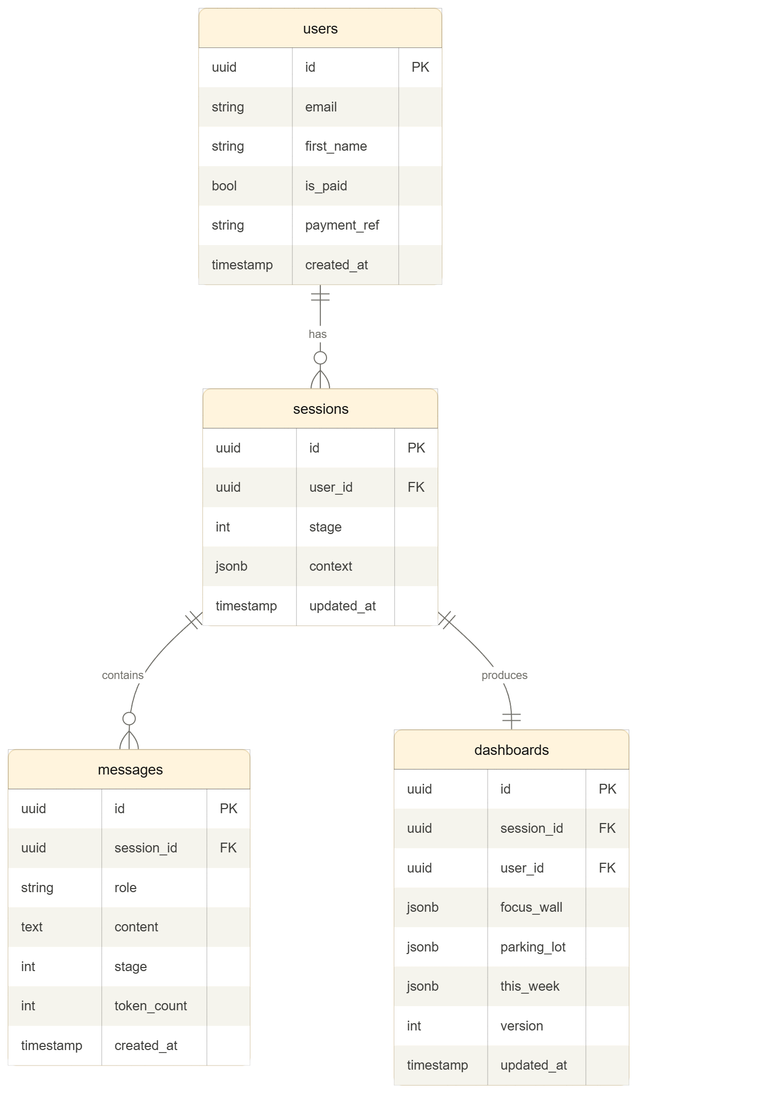

Three design decisions worth calling out in this schema:

sessions.stage is the state machine. It holds a single integer (0–4). On every return visit, the app reads this one field and routes accordingly: stage 4 → show dashboard; stages 1–3 → show chat with resume/restart option. This means the entire return visit logic is a single DB read, not a conversation replay.

sessions.context is a jsonb blob. It stores the Stage 1 calibration answers (startup stage, funding, co-founder status). These get prepended to every subsequent AI call so the challenge conversation is calibrated to the founder's actual situation — without re-asking the questions.

messages.token_count is nullable now, used later. You don't need cost tracking during validation. But storing the token count per message from day one means you can turn on cost-per-session analytics post-validation without a migration.
dashboards.version starts at 1. When Phase 2 lands (ongoing chat updates the dashboard), you increment this. The schema supports it without a table change.

Return visit state machine — in plain logic
User opens app
→ authenticated? No → homepage
→ authenticated? Yes → load session

session.stage === 4
→ render dashboard from dashboards table
→ show "Continue conversation" button (Phase 2: updates dashboard)
→ done

session.stage === 1, 2, or 3
→ load all messages from DB
→ show chat with history rendered
→ show banner: "You left mid-conversation. Resume or start fresh?"
→ Resume → continue with message history as AI context
→ Start fresh → soft-delete messages, reset stage to 0, new session row

session.stage === 0 (rare — closed immediately after clicking link)
→ drop them at Stage 0 as if new
No user ever sees a blank state. The banner handles the restart gracefully.

Cost — validation vs post-validation

During validation (20 free founders):
- Vercel: $0 (free tier)
- Supabase: $0 (free tier, Mumbai region available)
- Anthropic API: ~$0.10–0.20 per session × 20 sessions = $2–4 total
- Resend: $0 (free tier, 3k emails/month)
- Total: effectively $0

Post-validation, scaling to 100–200 weekly users:
- Vercel Pro: $20/month
- Supabase Pro: $25/month (point-in-time recovery, 14-day backups)
- Anthropic API: ~$0.15 per session × 800 sessions/month = ~$120/month
- Resend: $20/month
- Razorpay: % of revenue (no monthly fee)
- Total: ~$165–185/month — well inside ₹15,000/month, let alone your $500 ceiling

The stack doesn't need to change at 200 users. Vercel and Supabase both scale to that without configuration changes. The only cost that moves with users is the Anthropic API, and at $0.15/session it's the unit economics you actually want to be tracking.

One thing to agree on before your developer writes line 1: the sessions table should have a unique constraint on user_id for Phase 1 (one session per user). When Phase 2 introduces multi-session or re-challenge flows, you remove that constraint. Build the constraint in now so the Phase 1 invariant is enforced at the DB level, not just in application logic.

P0 Requirements — Build Now
These are the only things that need to exist before the 20-founder validation starts. Nothing else.

Authentication
- Magic link only — email to single-use token to session. No passwords, no OAuth.
- Session persists via JWT in a cookie (not localStorage) for 30 days.
User record: id, email, first_name, is_paid, payment_ref, created_at

Conversation Engine
- Streaming AI chat via Anthropic API (claude-sonnet-4). Streaming is non-negotiable — a 4-second wait kills the experience.
- Stage machine: app tracks which stage the user is in (0→1→2→3→4) as a backend integer, not a UI state.
- System prompts hardcoded in a config file for MVP. Not in a database.
- Hard token ceiling: 4,000 output tokens per session (~$0.06). One verbose founder does not cost $3.
- Rate limiting: max 3 concurrent AI requests per user, max 10 sessions per day. Prevents loops and abuse.

Conversation Persistence (return visit)
- Every message in Stages 1–3 saved to DB as it arrives: session_id, role, content, stage, timestamp.
- Returning user loads their existing dashboard if Stage 4 is complete.
- Mid-conversation (Stages 1–3): restore full message history with a resume/restart banner.
Without persistence, the product breaks on tab close. This is not optional.

Return Visit State Machine
The full logic on every app open:

Session stage | What the app does
4 (complete) | Render dashboard from DB. Show 'Continue conversation' button (Phase 2).
1, 2 or 3 | Load all messages from DB. Show chat with history. Banner: 'Resume or start fresh?'
0 (abandoned) | Drop them at Stage 0 as if new.
No session | Homepage — email entry.

Dashboard Generation and Storage
- At end of Stage 3, AI produces structured JSON: focus wall items (max 4), parking lot by category, This Week tasks.
- JSON stored in dashboards table linked to session. One generation per session.
- Dashboard rendered deterministically from stored JSON — never re-prompted on each visit.
- Task list: static in MVP, rendered from dashboard JSON, persisted to localStorage for in-browser edits only.

Payments (Validation Phase)
- During 20-founder validation: free. No payment gate.
- After validation, before public launch: Razorpay payment link (20-minute setup). You manually flip is_paid = true in DB after each payment.
- Full webhook-based subscription billing (Stripe/Razorpay) is post-validation — 2–3 days of work not needed for 20 users.
One nullable payment_ref column in users is all you need now to make this extensible later.

Basic Error Handling
- If Anthropic API call fails: clean error message in chat. 'Something went wrong — tap to retry.'
- 1 automatic retry on 5xx. Surface to user after that. No silent failures.
- Conversation history is already saved — retrying just re-sends from last saved state.

Frontend Decisions (before line 1 of code)
Decision | Choice | Why
Component library | Shadcn/ui | Unstyled enough to look like itself, not a template. Your dev knows it.
State management | Zustand | React state alone gets messy for multi-stage chat. Zustand is 1KB.
Markdown rendering | react-markdown + remark-gfm | AI returns markdown. Raw strings in UI look broken.
Router | Next.js App Router | Streaming is much cleaner than Pages Router. Non-negotiable.

Deployment
- Production: Vercel (free tier handles 20 users, zero config).
- Database + auth: Supabase (Postgres + magic link auth + Mumbai region ap-south-1).
- Environment variables: Vercel dashboard for prod, .env.local for local dev.
- Vercel creates a preview environment per branch automatically — use it from day one.

The Tech Stack

Layer | Choice | Notes
Framework | Next.js 14+ (App Router) | Your developer knows it. Streaming native. Vercel deploy is zero-config.
Hosting | Vercel | Free for validation. Scales to 200 users without architecture change.
Database + auth | Supabase | Postgres + magic link auth + Mumbai region. One provider for both.
AI | Anthropic API + Vercel AI SDK | SDK handles streaming, useChat hook, retry, message history format.
Email | Resend | $0 for first 3,000/month. Supabase auth uses it natively for magic links.
Payments | Razorpay (post-validation) | India-first, INR support, Stripe-like API. Manual links for validation phase.
UI | Shadcn/ui + Tailwind | Unstyled enough to look like itself, not a template.
State | Zustand | 1KB. Right choice for multi-stage chat with a dashboard.
Markdown | react-markdown + remark-gfm | For rendering AI responses in chat correctly.

Database Schema
Four tables. No more. Every column here earns its place.

users
Column | Type | Notes
id | uuid PK | Primary key
email | text unique | Used for magic link auth
first_name | text | Collected at signup for personalised Stage 0 greeting
is_paid | boolean | Manually flipped during validation; webhook-driven post-MVP
payment_ref | text nullable | Razorpay/Stripe payment or subscription ID — nullable now, used later
created_at | timestamptz | Auto-set

sessions
Column | Type | Notes
id | uuid PK | Primary key
user_id | uuid FK → users | Unique constraint in Phase 1 (one session per user, enforced at DB level)
stage | integer | The state machine: 0–4. Single field drives the entire return visit logic.
context | jsonb | Stage 1 calibration answers prepended to every AI call — startup stage, funding, co-founder status.
updated_at | timestamptz | Updated on every message write

messages
Column | Type | Notes
id | uuid PK | Primary key
session_id | uuid FK → sessions | Links message to its session
role | text | user or assistant
content | text | Full message content
stage | integer | Which stage this message belongs to (1, 2, or 3)
token_count | integer nullable | Nullable now. Stored from day one so cost analytics can be turned on post-validation without a migration.
created_at | timestamptz | Auto-set

dashboards
Column | Type | Notes
id | uuid PK | Primary key
session_id | uuid FK → sessions | One dashboard per session
user_id | uuid FK → users | Denormalised for fast lookup on return visit
focus_wall | jsonb | Array of max 4 focus items, each with goal, tag, and 3 tasks
parking_lot | jsonb | Object keyed by category, each item with name and reason parked
this_week | jsonb | Array of this-week tasks (static in MVP)
version | integer | Starts at 1. Increment when Phase 2 introduces dashboard updates via ongoing chat.
updated_at | timestamptz | Updated on any dashboard change

Cost Model

During validation (20 founders, free)
Service | Cost
Vercel | $0 (free tier)
Supabase | $0 (free tier, Mumbai region available)
Anthropic API | ~$0.10–0.20 per session × 20 sessions = $2–4 total
Resend | $0 (free tier, 3,000 emails/month)
Total | Effectively $0

Post-validation (100–200 weekly users)
Service | Monthly cost
Vercel Pro | $20
Supabase Pro | $25 (point-in-time recovery, 14-day backups)
Anthropic API | ~$0.15 × 800 sessions/month = ~$120
Resend | $20
Razorpay | % of revenue (no monthly fee)
Total | ~$165–185/month

Well inside ₹15,000/month, let alone the $500 ceiling. The stack does not change at 200 users — only the Supabase tier and Vercel plan change.

Build After Validation (P1)
Do not build these before the 20-founder validation is done. Each one is real but premature until you have proof the core flow works.

Razorpay subscription billing
- Webhooks, subscription status synced to DB, failed payment handling, dunning.
- Build before going past 20 users. Manual is_paid flipping does not scale.

Observability
- Conversation completion rate by stage — where do people drop off?
- Latency per AI call — is it 2s or 8s?
- Cost per session (actual, not estimated).
- Error rates on AI calls.
- Tool: PostHog (open source, self-hostable, cheap). Add after you have 20 data points to look at.

Chat UX polish
- Typing indicator while streaming starts.
- Optimistic UI — user message appears instantly.
- Scroll lock — auto-scroll during streaming, don't hijack if user has scrolled up to re-read.
- Mobile keyboard behaviour — iOS pushes input behind keyboard. Fix with dvh units and visualViewport API.
- Virtualised message rendering for long conversations (not needed at 20 users, needed at 200).

Security hardening
- CORS allowlist on API routes.
- Prompt injection protection.
- Anthropic's built-in content moderation is sufficient for MVP; a full layer is post-validation.

Data and privacy
- Conversation deletion (right to erasure).
- Data export — dashboard and conversation as JSON or PDF.
- Privacy policy referencing Anthropic's data usage terms.
- Data retention policy (decide: 90 days? 1 year?).

Product analytics
- Landing page conversion rate.
- Time to complete each stage.
- Which parking lot items founders promote most often — your core product feedback signal.
- Which focus wall items founders actually complete — the product's success metric.

Staging environment
- Separate Vercel preview + Supabase project.
- For validation: test in prod with test_ email prefixes. After validation, add staging properly.

Model fallback
- If Anthropic has an outage: show 'we'll be back shortly' message. Do not silently fall back to another model.
- The challenge conversation is tuned for Claude's behaviour. An opaque fallback produces inconsistent outputs.
- For 20 users, an outage is a support email, not an architecture problem.

Never Build

Feature | Reason
Free tier / freemium | Against the product's design principle. Founders who pay take the discipline seriously. Selection effect matters.
Progress bars in Stage 3 | Directly contradicts spec. Showing 'Step 3 of 5' undermines the advisor feel. The conversation does the work.
Slack / calendar integrations | The whole point is focus. Adding integrations is the product contradicting itself.
Team accounts | Explicitly post-MVP. One founder, one dashboard.
BYOK (Bring Your Own Key) | At ~$0.10 per session and 20 users, your API cost is $2. Not a problem to solve.
Co-founder share link | Genuinely useful. Genuinely post-MVP. Build it after the solo dashboard experience is proven.
Weekly check-in / commitment ritual | Explicitly out of MVP scope. Don't add until Stages 1–4 are proven.

Two Critical Pre-Build Decisions

1. Unique constraint on sessions.user_id
Add a unique constraint on user_id in the sessions table before your developer writes line 1. This enforces the Phase 1 invariant (one session per user) at the DB level, not just in application logic. When Phase 2 introduces re-challenge flows, you remove the constraint. Much easier to remove than to add later.

2. Token ceiling in the system prompt
Set max_tokens: 4000 on every Anthropic API call. Without a ceiling, one verbose founder can cost you $2–3 in a single session. At current Sonnet pricing, 4,000 output tokens is ~$0.06. 50 sessions = $3. Acceptable. This is a one-line config that must exist from day one.

Appendix

Considerations for building the tech stack

Good. I've gone through the full spec, the gaps list, and the sample conversation carefully. Before I classify, let me surface two genuine conflicts that need a decision — because they affect what "build now" means:
Conflict 1 — Task list: static or editable? The spec says the This Week list is static in MVP. The sample conversation ends with an editable list with localStorage, checkboxes, sub-items, and tab-indent. Those are two very different builds. I'll assume the sample conversation wins — an editable task list is core to the return visit experience, not a nice-to-have.
Conflict 2 — Payments for 20 founders The spec says "paid from day one, direct outreach to first 20 users." You don't need Stripe for 20 people — you can collect payment via Razorpay payment link and manually flip a is_paid flag in the DB. Full subscription billing is real engineering work. For 20 users, it's overkill and will slow you down. I'll flag both options.

P0 Requirements — Classified
🟢 Build Now (MVP)
Authentication
- Magic link auth (email → single-use token → session). No passwords.
- Session persists in a JWT stored in a cookie or localStorage. User shouldn't be asked to log in again for 30 days.
- User record in DB: id, email, created_at, is_paid, stage_completed
The conversation engine — this is the product
- Streaming AI chat (Anthropic API, claude-sonnet-4). Streaming is non-negotiable — a 4-second wait for a full response kills the experience. Streaming shows thinking in real time.
- Stage machine: the app knows which stage the user is in (0→1→2→3→4) and routes them correctly on return visit. Not a UI progress bar — a backend state.
- System prompts for each stage hardcoded in the codebase to start. Not in a DB. A config file is fine for 20 users.
- Token ceiling per session: hard cap at ~4,000 output tokens per session. One verbose founder should not cost you $3. At current Claude pricing, 4k tokens ≈ $0.06. 50 sessions = $3. Acceptable.
- Rate limiting: max 3 concurrent AI requests per user, max 10 sessions per day per user. Simple in-memory or Redis. Prevents any loop or abuse.
Conversation persistence (return visit experience)
- Every message in Stages 1–3 saved to DB as it arrives: session_id, role, content, stage, timestamp
- When a returning user opens the app, they see their existing dashboard — not the start of the conversation again
- If they're mid-conversation (e.g. abandoned mid-Stage 3), they return to exactly where they left off with full message history rendered
- This is not optional — without it, the product breaks on tab close
Dashboard generation and storage
- At the end of Stage 3, the AI produces structured output (JSON) containing: focus wall items (max 4), parking lot items by category, This Week tasks
- This JSON is stored in DB as a dashboard record linked to the session
- The dashboard page reads from DB, not from a re-generated AI call. One generation per session. Regeneration is post-MVP.
- Dashboard is rendered deterministically from stored JSON — not re-prompted each visit
The dashboard UI
- Founder's Trap alert: permanent, non-dismissible, top of page
- Focus wall: 4 items max, each with goal, tag, and 3 tasks
- Parking lot: organised by category, each item shows the one-line reason
- This Week task list: editable in-browser, with checkboxes, tags, sub-items (tab/shift-tab), and localStorage persistence. This is the one place localStorage is the right call — it's personal, ephemeral, and doesn't need server sync for MVP
- Markdown rendering for AI responses in chat (the AI will return bold, bullets — raw markdown looks broken)
Payments
- For 20 founders: do not build Stripe subscriptions. It's 2–3 days of work for 20 manual customers. Instead — Razorpay payment link (takes 20 minutes to set up), and you manually set is_paid = true in the DB after each payment. Build a simple check: if is_paid is false, the user hits a gate page after Stage 0.
- Design the DB schema so Stripe/Razorpay subscription ID can be added later without a migration. One extra nullable column now saves you pain later.
- Full subscription billing (Stripe webhooks, dunning, failed payment handling) is post-validation.
Basic error handling
- If the Anthropic API call fails, show a clean error message in the chat: "Something went wrong — tap to retry." The user's conversation history is already saved, so retrying just re-sends from the last saved state.
- No silent failures. No broken partial messages with no recovery path.
- Simple retry: 1 automatic retry on 5xx, then surface the error to the user.
Frontend fundamentals (decisions that must be made before line 1 of code)
- Component library: Shadcn/ui. Your developer knows Next.js — Shadcn is the standard choice, zero licensing issues, unstyled enough that the product can look like itself. Not Chakra, not MUI.
- State management: Zustand. React state alone gets messy for a multi-stage chat app with a dashboard. Zustand is 1KB, your dev knows it if they know Next.js.
- Markdown: react-markdown with remark-gfm. One package, well maintained.
- Next.js App Router (not Pages Router). Your dev should be on this already — streaming is much cleaner in App Router.
Deployment and environments
- Prod on Vercel (free tier handles 20 users easily, scales without config change)
- Managed Postgres: Supabase free tier for validation (20 users fits easily, 7-day backup retention is fine for this stage)
- Environment variables: Vercel dashboard for prod, .env.local for local. Not complicated. Don't over-engineer this for 20 users.

🟡 Build After Validation (post-20 founders)
Observability
- Conversation completion rate by stage (where do people drop off?)
- Latency per AI call
- Cost per session (actual, not estimated)
- Error rates
- PostHog is the right tool — open source, self-hostable, cheap. Add it after you have 20 data points to look at.
Stripe subscription billing
- Webhooks, subscription status synced to DB, failed payment handling, dunning
- Build this before you go past 20 users — manual is_paid flipping doesn't scale past that
Full chat UX polish
- Typing indicator while streaming starts (the "thinking" dot animation)
- Optimistic UI (user message appears instantly before server confirms)
- Scroll lock: auto-scroll during streaming, but don't hijack if user has scrolled up
- Reconnection handling for dropped connections mid-stream
- Mobile keyboard behaviour (iOS pushes input behind keyboard — fixable with dvh units and visualViewport API)
- Virtualised message rendering for long conversations (not needed at 20 users, needed at 200)
Staging environment
- Separate Vercel preview + Supabase project for staging
- For 20 users you can test in prod carefully with a test_ email prefix. After validation, add staging properly.
Model fallback
- If Anthropic has an outage, show a clear "we'll be back shortly" message. Do not silently fall back to GPT-4 — the challenge conversation is tuned for Claude's specific behaviour. An opaque fallback produces inconsistent outputs. For 20 users, an outage is a support email, not an architecture problem.
Prompt versioning
- Move system prompts from config file to DB with version tracking
- Required before you start A/B testing challenge conversation styles
Security hardening
- CORS allowlist (currently open)
- Prompt injection protection (system prompt leakage via adversarial input)
- Content moderation (Anthropic's built-in moderation is enough for MVP; a full moderation layer is post-validation)
Data and privacy
- Conversation deletion (GDPR right to erasure)
- Data export (dashboard + conversation as JSON or PDF)
- Privacy policy referencing Anthropic's data usage terms
- Data retention policy (decide: 90 days? 1 year?)
Product analytics
- Landing page conversion rate
- Time to complete each stage
- Which parking lot items get promoted most often (this is your product feedback signal)
- Which focus wall items founders actually complete
Email sequences
- Day 4 nudge: "Did you complete your four things? Your dashboard is waiting."
- This drives the weekly return behaviour that makes the product sticky
Admin panel
- A simple internal page (auth-gated) to see all users, their stage, paid status, and session count. Write raw SQL queries until you have 50 users. After that, build a basic admin view.

🔴 Never Build
Free tier / freemium — explicitly against the product's design principle. Selection effect matters: founders who pay take the discipline seriously.
Progress bars during the challenge conversation — directly contradicts Stage 3 design rules. The conversation does the work; showing "Step 3 of 5" undermines the advisor feel.
Slack / calendar integrations — not in spec, and wrong for this product. The whole point is focus. Adding integrations is a distraction.
Team accounts — explicitly post-MVP. One founder, one dashboard.
BYOK (Bring Your Own Key) — spec says P2. For MVP with 20 users at ~$0.10 per session, your API cost is $2. Not a problem to solve now.
Co-founder read-only share link — genuinely useful, genuinely post-MVP. Build it after you've confirmed the solo dashboard experience works.
Weekly check-in / commitment ritual — explicitly out of MVP scope. Don't add it until the Stage 1–4 flow is proven.

Two things I'd flag before Stage 2 (architecture)
1. The "return visit" state machine is the most underspecified thing in the spec. What does the app do when a founder returns? Does it show the dashboard if Stage 4 is complete? Resume the conversation if mid-Stage 3? Restart if they abandoned mid-Stage 2? This decision shapes the entire session and DB model. Need a clear answer before architecture.
2. One-dashboard or multi-session? Can a founder run a new brain dump next week and get a new dashboard? Or is it always the same dashboard, edited over time? The spec implies one dashboard per user with no regeneration in MVP, but that means a founder who completes Stage 4 has no path to update their priorities other than editing tasks manually. Is that acceptable for the 20 founder validation? Worth deciding now before the schema is set.
Answer these two and I'll move to architecture.

